**St. Paul’s Catholic Primary School**

**Part of Bishop Bewick Catholic Education Trust**



**Growing in God’s Love to Be the Best We Can Be**

**PACKED LUNCH POLICY**

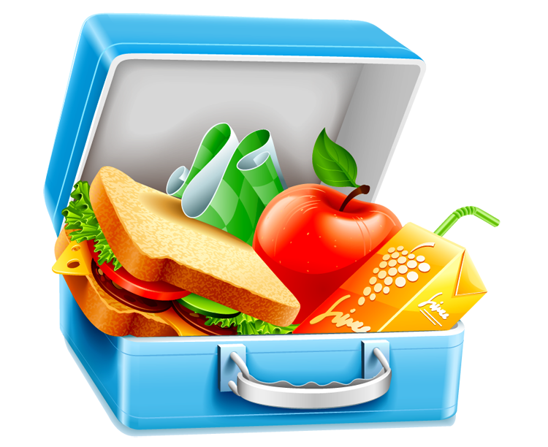

|  |  |  |
| --- | --- | --- |
| **Approved by:** | Mrs F Sinclair (Chair of Governors) | **Date:** July 2023 |
| **Last reviewed on:** | July 2023 | |
| **Next review due by:** | July 2025 | |

**PACKED LUNCH POLICY**

**Rationale:**

To ensure that all packed lunches brought from home and consumed in school (or on school trips) provide the pupils with healthy, safe and nutritious food. Schools are required to positively promote the health and well-being of their pupils. Work around healthy eating is a high priority of the Government’s Strategy which outlines an expectation on all schools: To promote a culture of healthy eating the government now expects all schools, in consultation with parents, pupils and staff, to adopt whole school food policies. Schools will be expected to develop healthy packed lunch policies so that those not yet taking up school lunches are also eating healthier. The content of lunchboxes needs to reflect the requirement of schools to meet minimum food and nutrition standards for school meals. Packed lunches should provide a nutritious, balanced diet to support the child’s learning and development.

**Aims:**

* To ensure that packed lunches (brought in from home) reflect the standards for school meals updated in March 2019 [www.gov.uk/school-meals-healthy-eating-standards](http://www.gov.uk/school-meals-healthy-eating-standards)
* To encourage a high nutritional quality of packed lunches in schools and healthy eating habits of children at lunchtimes, that can influence health and well-being.
* To further raise the profile of healthy eating throughout the school.
* To encourage healthy eating habits from an early age and improve the overall nutrition of pupils

**What the school will provide:**

* an appropriate area where pupils who choose to bring packed lunches can eat.
* ensure that eating packed lunches is a sociable experience for children and that they learn and use a high standard of table manners.
* the school will ensure that tables where pupils eat their lunches in the dining hall are tidy and hygienic.
* a storage area / facilities for packed lunch bags, in the most convenient and appropriate place possible. However, the school cannot provide cooled storage areas and therefore cannot take legal responsibility for foods prepared at home and then brought into school.
* fresh drinking water that is available at all times.
* the school will, within reason, send any uneaten packed lunch food items back home. The rationale for this is that parents can also monitor what their child has consumed during the day and then raise any concerns over their child’s food intake with the school.
* the school will ensure that staff supervising pupils eat packed lunches are aware of food hygiene procedures.

**Guidance**

**Suggestions for food to include in a healthy packed lunch:**

• At least one portion of fruit or vegetables every day (These foods provide vitamins, minerals and fibre)

• Meat, fish, eggs or other source of non- dairy protein (e.g. lentils, beans, soya or hummus) every day (usually as part of a sandwich, wrap, roll or salad

• Oily fish such as tuna or salmon (These foods provide protein for growth)

• A starchy food such as bread, pasta, rice, potatoes or other types of cereals every day (These starchy foods are a healthy source of energy)

• Dairy food such as milk, cheese, yoghurt or fromage frais (These foods provide calcium for healthy bones and teeth)

• A drink – water is best followed by milk (semi-skimmed), unsweetened fresh fruit juice, diluted fresh fruit juice, drinking yoghurt or dairy based smoothies.

• Cereal bars rather than cakes and biscuits

• Pretzels, seeds, fruit, crackers and cheese and vegetable or bread sticks with a dip.

**Suggestions for food less often in a healthy packed lunch**

• Meat products such as sausage rolls, individual pies, corned meat and sausages/chipolatas

• Cakes

• Crisps

• Biscuits

**Packed Lunches should not include:**

• Fizzy/highly sugared drinks in cartons, bottles or cans

• Sweets/confectionary

• Chocolate spread as a filling for sandwiches

• Chewing gum

• Energy drinks

• Nuts or nut products because of the danger to other children with allergies

• Hot food – due to the health and safety concerns relating to food poisoning and scalding. Hot food must be kept at a temperature of not less than 75 degrees Celsius in order to prevent the development of dangerous bacteria. The school has no facilities to maintain or monitor required temperatures for hot packed lunches. Staff and other children are at risk of scalding if hot foods/soups are spilled in the dining room.

**Special Diets**

The school recognises that some pupils may require special diets due to verified medical conditions. In this case, parents are urged to inform the school and be responsible in ensuring that packed lunches are as healthy as possible. For these reasons, children must eat their own and no-one else’s packed lunch.

**Packed Lunch Containers**

We ask that parents/carers and pupils:

* provide a packed lunch container where food items can be stored securely and appropriately until the lunchtime period.
* bring packed lunches in reusable plastic containers, rather than disposing of plastic bags and bottles.
* Fridge space for packed lunches is not available so it is advisable to bring packed lunches in insulated bags with an ice pack to keep the food fresh.

**Waste and disposal**

The school will, within reason, send any uneaten packed lunch food items back home. The rationale for this is that parents can also monitor what their child has consumed during the day and then raise any concerns over their child’s food intake with the school.

**Monitoring and Evaluation**

Packed lunches will be regularly monitored and reviewed by Senior Leaders/classroom staff / catering staff/midday meal supervisors. Parents and pupils who do not adhere to the Packed Lunch Policy will be asked to take home items of food that do not follow our policy. Parents will receive reminders of the Policy. If a child regularly brings a packed lunch that does not conform to the policy, then the school will contact the parents to discuss and find a solution to this.

**Useful Websites**

Guidance on healthier snacks and packed lunches:

[www.gov.uk/school-meals-healthy-eating-standards](http://www.gov.uk/school-meals-healthy-eating-standards)

<http://www.nhs.uk/Livewell/childhealth6-15/Pages/Lighterlunchboxes.aspx>

This policy has been developed by our Well Being Ambassadors, staff and governors. Our Well Being Ambassadors have also produced leaflets and resources to support parents as well as presentations to the whole school community to promote healthy lunch boxes.