**St. Paul’s Catholic Primary School**

**Part of Bishop Bewick Catholic Education Trust**



**Growing in God’s Love to Be the Best We Can Be**

**EARLY YEARS ADMISSIONS POLICY**

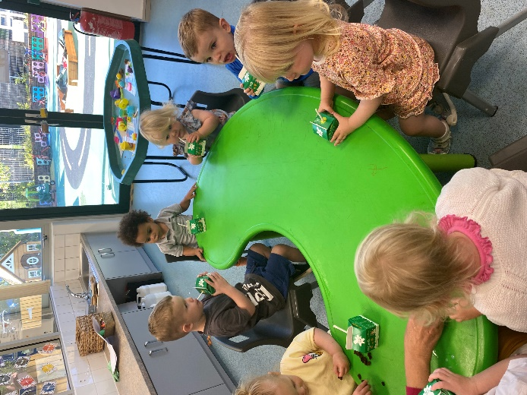

|  |  |  |
| --- | --- | --- |
| **Approved by:** | Mrs F Sinclair (Chair of Governors) | **Date:** February 2024 |
| **Last reviewed on:** | February 2024 | |
| **Next review due by:** | February 2025 | |

**EARLY YEARS ADMISSIONS POLICY**

**Mission Statement:**

St. Paul’s Catholic Primary School is a vibrant Christian community at the heart of which is a love for God. It respects the uniqueness of the individual made in God’s image and loved by him and this is immersed in our core values of faith, respect, resilience and happiness.

We aim to deliver a high standard of education which challenges all, based on the understanding that the whole person is celebrated and inspired to contribute.

We aim for excellence in the daily life of our school, where together we live, love, learn and celebrate.

In working outwardly, our partnership with parents, our parishes, other schools and the wider community, will benefit.

We will endeavour to provide open and supportive communication which fosters effective, caring relationships between all.

***“Growing in God’s Love to Be the Best We Can Be”***

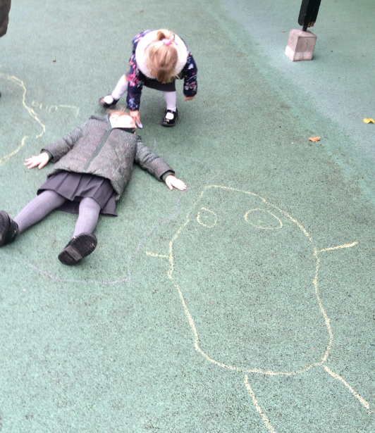

*We have been learning about how we are all unique and special.*

**1.Statement of Intent:**

At St. Paul’s Catholic Primary School we aim to provide high quality early years education and flexible childcare. We provide care for children between 2-4 years of age within our two classes. “Little Lambs” is our 2-3 year old provision which works closely alongside our Nursery Class. Both classes aim to provide a high quality nursery experience for children that is geared towards a smooth transition into the next phase of education.

Our EYFS Lead is Miss Jorgensen and she works closely with the Early Years staff to ensure the children receive ambitious learning opportunities and excellent pastoral care to attain school readiness by the end of Nursery year.

The local governing committee is the admission authority and is responsible for setting the school’s Nursery Admissions Policy. This policy is written to ensure fairness and equality for all those intending to begin their education at the school. This policy has due regard to legislation and guidance including, but not limited to, the following:

• Childcare Act 2006

• Childcare Act 2016

• Data Protection Act 2018

• The General Data Protection Regulation

• DfE (2014) ‘School Admissions Code’

• DfE (2012) ‘School Admission Appeals Code’

• DfE (2018) ‘Early education and childcare’

• DfE (2018) ‘Early years entitlements: operational guide’

St. Paul’s Catholic Primary School offers extended provision if required. We are open Monday-Friday 8.00am - 5.30pm, term time only.



*Investigating water at The Alnwick Garden*

**2. Application Process for three and four year olds**

**2.1.Waiting List**

Parents may register their interest in a place at the nursery at any time following their child’s birth, by contacting the school office. The child’s birth certificate will be required as proof of their date of birth. These children will be entered on a waiting list to be considered for a place when they reach the appropriate age. Placing a child’s name on the waiting list does not guarantee that a place will become available for the child. The date on which a child was added to the waiting list will not be taken into consideration when places are offered.

**2.2. Offering Places**

Nursery intake will take place in both September and January each year. Places for the September intake will be offered during the preceding Summer term, to children who will be three by 31st August of that year.

Places for January intake will be offered during the Autumn term, to children who have turned three by the December of that year.

If places are available, children are welcome to join at any time during the academic year.

If there are more children on the waiting list than places available, priority will be given by the Governors in line with the Oversubscription Criteria – see section 3.3.

Places will be offered by contacting parents by letter using the contact details provided. If no response is received within 4 weeks of making the offer, the place may be offered to another child on the waiting list.

**3.3 Oversubscription Criteria**

Where there are more applications for places than the number of places available, places will be offered according to the following order of priority.

1. Catholic looked after and previously looked after children. (see notes 2&3)
2. Catholic children who are resident in the parish(es) of St. Paul’s, Alnwick, The Sacred Heart and St. Cuthbert, Amble, St. Mary’s, Whittingham, St. Aidan’s, Seahouses, St. Ninian’s, Wooler, All Saints, Thropton.

3. Other Catholic children. (see note 3)

4. Other looked after and previously looked after children. (see note 2)

5. Catechumens and members of an Eastern Christian Church. (see notes 4&5)

6. Children of other Christian denominations whose membership is evidenced by a minister or faith leader. (see note 6)

7. Children of other faiths whose membership is evidenced by a minister or faith leader. (see note 7)

8. Any other children.

*Within each of the categories listed above, the following provisions will be applied in the following order.*

1. *Where evidence is provided at the time of application of an exceptional social, medical or pastoral need of the child which can be most appropriately met at this school, the application will be placed at the top of the category in which the application is made. (see note 11)*
2. *The attendance of a sibling at the school at the time of enrolment will increase the priority of an application within each category so that the application will be placed at the top of the category in which the application is made after children in (i) above*

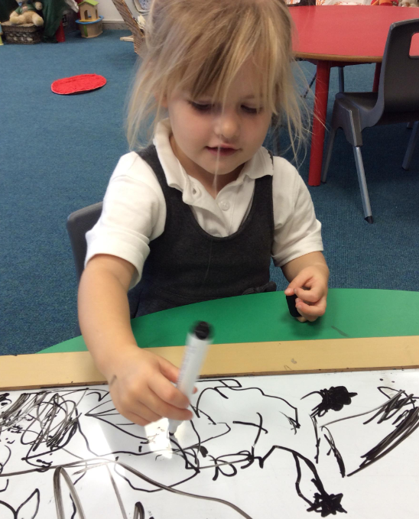

**3. Application Process for two and three year olds (Little Lambs)**

**3.1 Waiting List**

Parents may register their interest in a place at the nursery at any time following their child’s birth, by contacting the school office. The child’s birth certificate will be required as proof of their date of birth. These children will be entered on a waiting list to be considered for a place when they reach the appropriate age.

**3.2 Offering Places**

Parents will be contacted by email or phone during the term before the child is eligible for a place to check they still want to access St. Paul’s Little Lambs provision. A date will be arranged for a school visit to complete a tour of the school, registration information and consent forms.

**3.3 Oversubscription Criteria:**

Where there are more applications for places than the number of places available, places will be offered according to the following order of priority.

1. Catholic looked after and previously looked after children. (see notes 2&3)
2. Catholic children who are resident in the parish(es) of St. Paul’s, Alnwick, The Sacred Heart and St. Cuthbert, Amble, St. Mary’s, Whittingham, St. Aidan’s, Seahouses, St. Ninian’s, Wooler, All Saints, Thropton.

3. Other Catholic children. (see note 3)

4. Other looked after and previously looked after children. (see note 2)

5. Catechumens and members of an Eastern Christian Church. (see notes 4&5)

6. Children of other Christian denominations whose membership is evidenced by a minister or faith leader. (see note 6)

7. Children of other faiths whose membership is evidenced by a minister or faith leader. (see note 7)

8. Any other children.

*Within each of the categories listed above, the following provisions will be applied in the following order.*

1. *Where evidence is provided at the time of application of an exceptional social, medical or pastoral need of the child which can be most appropriately met at this school, the application will be placed at the top of the category in which the application is made. (see note 11)*
2. *The attendance of a sibling at the school at the time of enrolment will increase the priority of an application within each category so that the application will be placed at the top of the category in which the application is made after children in (i) above*

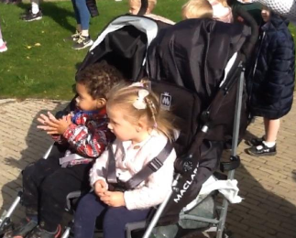

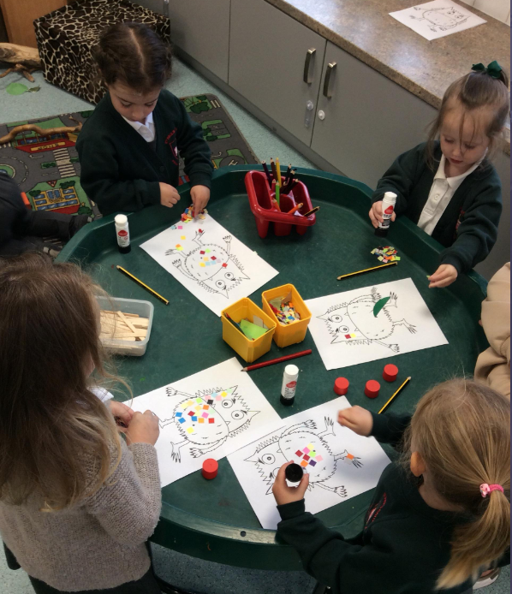

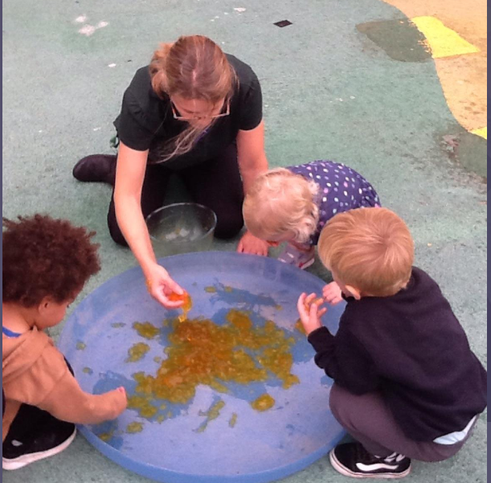

**5. Admission to Reception Class**

Children who attend the Nursery do not have an automatic place in our Reception class and should apply through Northumberland County Council Admissions. It is the responsibility of the parents to apply for a school place. See the School Admission Policy for more details.

**6. Data Protection**

All personal data will be held in line with the School Data Protection Policy and Privacy Notice.

